CISC320 Algorithms Your name: __________________________________
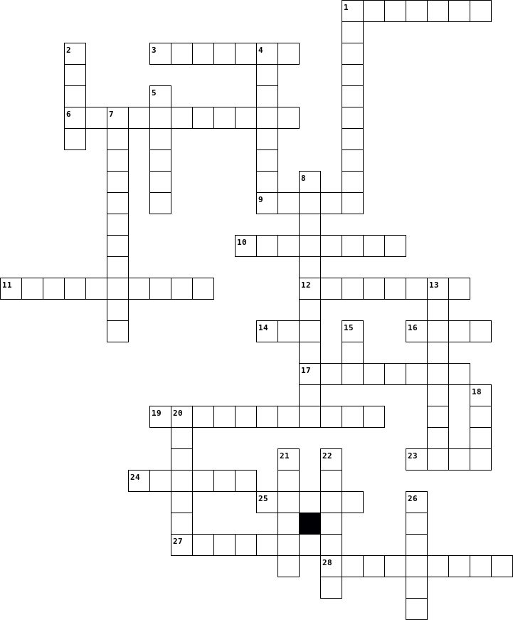

Clues
Across  1. A well-specified description of the complete set of instances, solved by an algorithm.  3. A type of language that can be used to express algorithms in a loose style.  6. A reordering of an existing collection.  9. A fixed-sized ordered collection of distinctive items.  10. A type of problem where the answer is a yes or no.  11. A property of algorithms indicating how much time or memory is needed.  12. A single input and its matched output for a problem.  14. The best dog.  16. A single instance or set of instances for a problem.  17. A pair of numbers indicating a range.  19. A property of algorithms indicating whether or not they satisfy all instances of a problem.  23. A collection with hierarchy and parent-child relationships between elements.  24. The specific values or desired characteristics of the values provided in a problem.  25. A formal, persuasive explanation of why an algorithm has a certain property.  27. An ordered collection of generic items with the same type.  28. A proposed solution to a problem. |  | Down  1. A type of language that balances expressivity with flexibility.  2. A collection with edge relationships between nodes.  4. Someone who solves problems.  5. An arithmetical value representing a quantity.  7. A property of algorithms indicating how easy they are for humans to understand.  8. A type of problem where there is a best solution among alternatives.  13. A symbol in a language.  15. An unordered collection of generic items with the same type.  18. A language where algorithms are expressed so formally that a computer can execute them.  20. The specific values or desired charactierstics of the values expected from solving a problem.  21. An ordered collection of characters.  22. A value that is either true or false.  26. A type of problem where the output is an element of the input.

